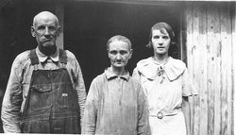
James Madison Burton, his wife Maude Mae (Dickerson) Burton and dau. Letha M. Burton
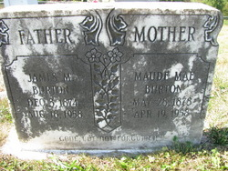
Big Sand Cemetery, Indian Valley, Floyd Co., VA
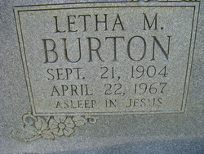
Leatha M. Burton, d/o James Madison & Maude Mae (Dickerson) Burton. Big Sand Cemetery, Indian Valley, Floyd Co., VA
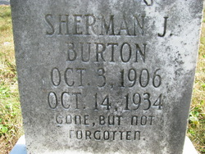
Sherman J. Burton, s/o James Madison & Maude Mae (Dickerson) Burton. Big Sand Cemetery, Indian Valley, Floyd Co., VA

